Mac MySQL Setup Guide

In order to setup MySQL Mac, we need to perform following steps:

1. First we need to go to <https://dev.mysql.com/downloads/mysql/5.7.html#downloads> click on download at Download under community Downloads. Once you’re redirected we need to click on Download once you scroll down below.



1. Skip the login and signup part and go straight to the “**No thanks, just start my download” link**
2. Next click on the DMG, it will verify the app and then you need to click on the continue on screen you see next.

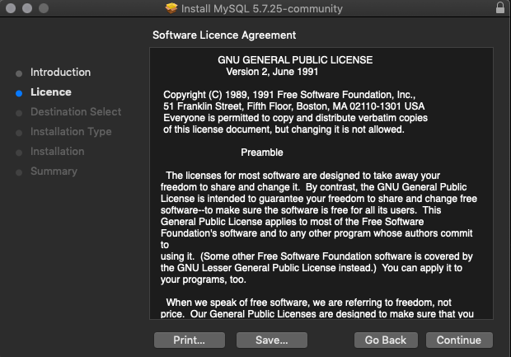

4. Now, we need to click on install at the next window:

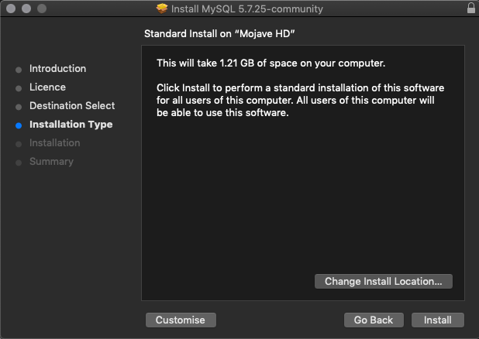

5. Then we need to provide the authorization. Wait for it complete. It will generate a temporary password, Keep it safe somewhere. A window will open like this to show temp password

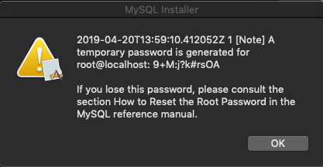

Once finished, we will get to see following window:

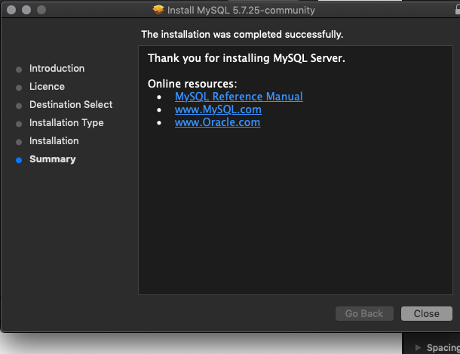

6. Now that we’ve that installed, we need to run the mysql service. Type command + space and look for mysql. Click where it says mysql preferences. you will see this window:

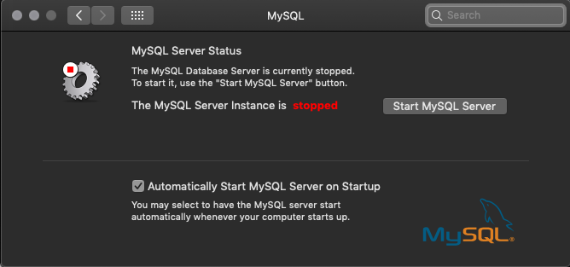

Click on Start MySQL Server button. If you want server to startup at every boot select the check mark. If the MySQL start was successful you will get the following window

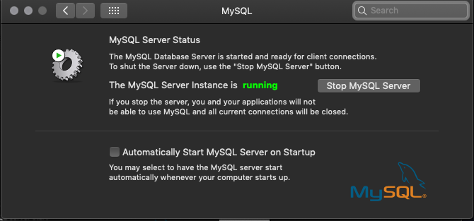

By default, MySQL binary cannot be executed from path so we have to add this to it, do this by running :

export PATH=$PATH:/usr/local/mysql/bin

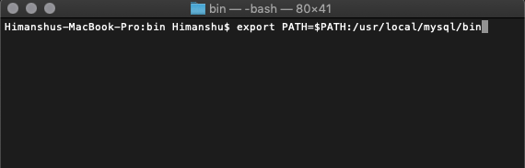

This will let us execute mysql commands from prompt in next section.

We would need to change the root password because that password seems to be tough and temporary. So run following command:

mysqladmin -uroot -p9+M:j?k#rsOA password ‘Password'

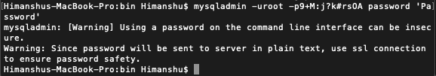

I have set the password to be Password.. Not recommended :P but this is a demo so yep :P

Now next steps:

**Creating Database, Connecting to Database,**

Connecting to MySQL and creating Database.

To connect to database you need to run following command:

**mysql -u root -p**

You will be prompted for root password, enter the same and hit enter.

Let’s create new DB. run:

create database newdb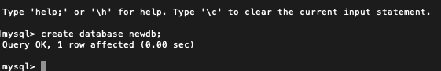

Next let’s create our user and grant him the privileges altogether in one command

Next, create create a user and grant all privileges and create a new User. let’s run the command below to do so:

**GRANT ALL PRIVILEGES ON newdb.* TO 'mashrur'@'localhost' identified by ‘Password’;**

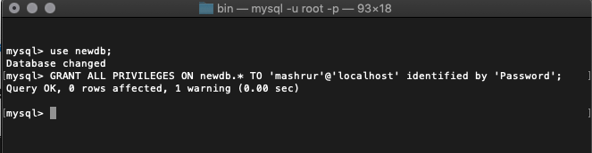Type \q to exit the mysql console

Now we’re able to login to our database using following command:

**mysql -u mashrur -p** and than provide the password you shall see the following screen

Let’s create the table :)

first use the new db, run :

**use newdb;**

than let’s create table, run following command:

**create table tasks(task_id INT, title VARCHAR(255) NOT NULL);**

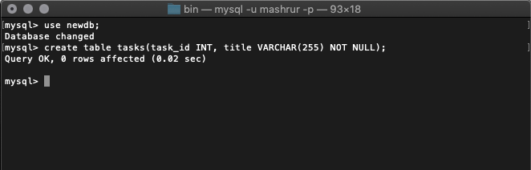

The above table will create the table tasks with task id as INT, title as VARCHAR

That’s all we’ve created our DB, Created a user and connected to it. Moving ahead, we had created created a table and granted privileges etc….